Access DataBase for Visual Basic 5/6 Step by Step
by Santiago Favaro – 22/01/2003

Versión: 0.2 Beta

Initialize the controls
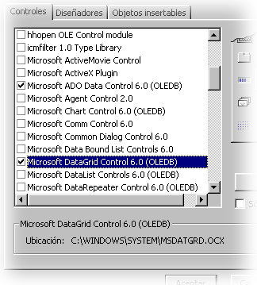
1.- To begin started must open Visual Basic, create a new project and then add the needed controls. To add this controls we must select Components... from the menu Project or press only ctrl.+ T. The needed controls are the Microsoft Ado Data Control 6.0 (it’s the mainly, and his function is to import the data from the Access Database and link it data to another controls like a Label, a PictureBox or a textBox) and the Microsoft DataGrid Control 6.0 (add the last one if you wanna show the linked data like a Excel sheet).

Putting the controls in the form and linking

2.- To continue we must put the AdoDC in our form, this will be the mainly control to use a DataBase.

3.- Then, we must link this control with our DataBase created with Access 97 or 2000. To do this, we have to do right-click over the AdoDC in our form and select Propertys of AdoDC.

Ok, when the dialog box appears we must select the Generate a conexión string and then do click in the button Generate (the function of this string is to say to the control what DataBase we like to link).

In the second dialog box we must check we are in the tab Provider, in this one we will select the type of Database we are using (in this case the type of DataBase will be an Access DataBase), because we are using an Access DataBase we must select the Microsoft Jet 3.51 OLE DB Provider option. Do click in Next.

Now, we are in the tab Conection where we must indicate to the AdoDC where our database is. Do click in the button “...” and find our database. If you don’t wanna make this path fix, you can write the path to the database like this: if our database is in c:\windows\data\base.mbd and our program is in c:\windows we can write the next path in the textbox datos\base.mdb. (without the c:\windows\).

If you wanna check that you did all OK, try to do click in the button Check Conection, it will say to us if the link can be done. If all are right press button OK to come back to the first dialog box.

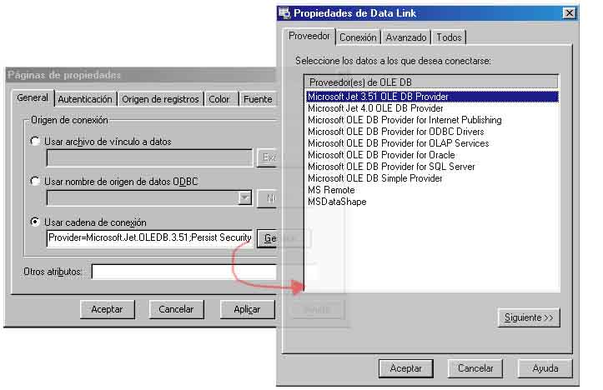
In the first dialog box we must to select the tab Data Origin (is a bad traduction, but I mean the third tab from left to right) and select in the first combolist the 2- adCmdTable option to say to the control that we want to import a table from our database. Next, we must select in the bottom combolist the name of the table we want to import. When you do all this press Ok buttom and continue to the next step.

Connect the AdoDC to controls to show the linked data

4.- If you wanna show the linked data of the database in differents controls (like a label, textbox, etc.) you must add an amount of labels same as the amount of fields that we wanna show.

5.- For each Label we must edit the next properties:

AutoSize: True (to auto adjust the size of the control)
DataSource: Adodc1 (indicates the name of the control that we linked with the databse, in our case is AdoDC1)
DataField: Name (is the name of the field that we want to link to this control)

It’s ready. Now all the labels are linked with a unique field of our database. You can see the result running the progran and then travel trought the diferents registers with the arrows of the AdoDC.

